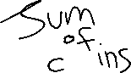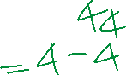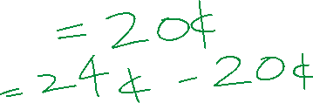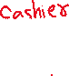

1. Take input from user store in a variable named change.
2. If input greater than 25, set count =1, subtract 25 from change,
3. Repeat 2, if input still greater than 25.
4. If input greater than 10, set count =1, subtract 10 from change,
5. Repeat 4, if input still greater than 10.
6. If input greater than 5, set count =1, subtract 5 from change,
7. Repeat 6, if input still greater than 5.
8. If input greater than 1, set count =1, subtract 1 from change,
9. Repeat 8, if input still greater than 1.